**Vaibhav Agarwal XI-D**

**Q10 Sum of odd and product of even positioned digits**

**Code**

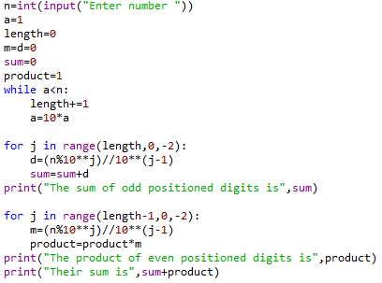

**Output**

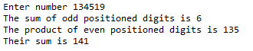

**Q11 Multiples of 7 but not 5**

**Code**

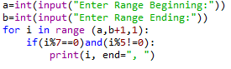

**Output**

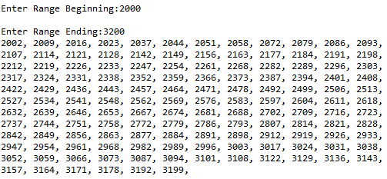

**Q12 Classifying students according to age**

**Code**

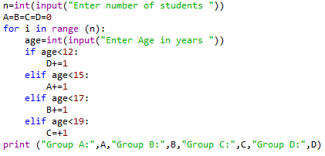

**Output**

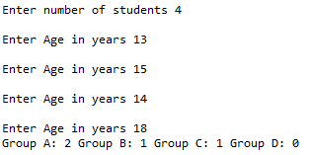

**Q13 Checking for valid ISBN**

**Code**

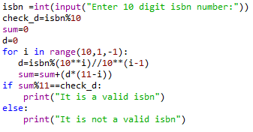

**Output**



**Q14 Checking a number for palindrome**

**Code**

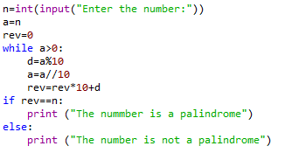

**Output**





**Q15 HCF of 2 numbers**

**Code**

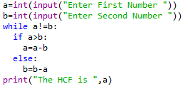

**Output**

